**EMPATHY EMOTION AND PERSONALITY DETECTION IN INTERACTIONS (INCLUDING REGRESSION PROBLEMS AND CLASSIFICATION PROBLEMS)** CW1

**ABSTRACT**

This research explores the role of empathy, emotion, and personality traits in human-computer interactions (HCI). The goal is to develop and test a machine-learning framework for detecting and analyzing these factors in HCI data. This approach may help improve the design of human-computer interaction systems by better understanding user needs and preferences. Ultimately, the findings of this research may lead to more empathetic and emotionally intelligent systems that are more engaging and satisfying for users.

**1.0 INTRODUCTION**

The detection of empathy, emotion, and personality within textual interactions represents a critical frontier in Natural Language Processing (NLP). By unlocking these dimensions, we gain profound insights into the intricate tapestry of human communication. Despite their significance, quantifying these attributes presents a significant challenge, resulting in a dearth of research compared to areas like sentiment analysis or hate speech detection. Nonetheless, recognizing their importance is paramount for achieving a more comprehensive understanding of human communication.

Empathy, a foundational human emotion, allows us to comprehend the emotional and mental states of others. It fosters deeper social connections and promotes amicability, making it a pivotal aspect of conversations. Accurate identification and understanding of empathy can significantly enhance the effectiveness of NLP models in capturing the nuances of human expression.

The detection of distress within communication is crucial as it signals discomfort, paving the way for timely interventions to alleviate potential suffering. Precise distress detection, therefore, plays a vital role in fostering well-being and peace within society.

This work contributes to solving a critical NLP problem through the application of machine learning for empathy, emotion, and personality detection in interactions. The WASSA 2023 Empathy, Emotion, and Personality Detection Shared Task provided a valuable platform for this exploration. The task aimed to develop models capable of predicting several key targets, including empathy, emotion, personality, and interpersonal index. These predictions were based on essays written in response to news articles highlighting challenging situations, along with perceived emotions and empathy within subsequent conversational exchanges.

The task focused on detecting Emotional polarity, Emotion, and Empathy from source essays with a length of approximately 8,000 words. These essays addressed real-world scenarios where individuals, groups, or entities faced difficulties. The dataset additionally provided annotations for various attributes such as Empathy, Emotions, and Emotional polarity. Building upon the success of pre-trained language models like BERT (Devlin et al., 2019) in various NLP tasks, we experimented with a range of such models, potentially including those incorporating additional pre-training for domain-specific adaptation. Furthermore, we explored ensemble-based approaches, where combining model outputs can often yield superior results compared to individual models. The following sections will detail the evaluation of these approaches, presenting the results and key observations.

**2.0 RELATED WORK**

Litvak et al. (2016) identify that monitoring social and linguistic behaviour through empathy monitoring hasn’t gained much attention and that there is a huge scope for further research. A Poisson regression model has been utilized to determine how social and linguistic behaviour relates to the attribute of empathy. To better comprehend empathy, Davis’ Interpersonal Reactivity Index (IRI), which considers 4 factors (namely fantasy, personal distress, empathetic concern, and perspective taking) has been used. Gibson et al. (2016) utilize empathy in addiction counselling.

The sessions' transcripts are used to train a model and predict empathy. Naturally, high empathy is desirable from a counsellor toward the client. The model is trained in two parts, firstly a Recurrent Neural Network is trained on a group of certain behavioral acts and then this is used to train the final Deep Neural Network. This approach is shown to have produced better results than training the Deep neural network all at once.

Hosseini and Caragea (2021) identify that it can be difficult to annotate data to identify empathy when working on a large scale. To integrate knowledge from the available resources and detect empathy from the natural language in several domains, this study uses multi-task training with knowledge distillation. Results on the TwittEmp dataset produce significantly better results using this approach. Saleem et al. (2012) recognize that psychological distress is seldom sufficiently identified. It offers ways to detect distress indicators and assess the severity of the distress. Text from online forum posts where individuals discuss their thoughts more freely is used. SVMs are used to identify distress indicators.

Guda et al. (2021) utilize user demographics to create an EMPATH-BERT framework for empathy detection. Internally it uses the BERT model, the framework is shown to surpass existing machine learning techniques. This paper allows us to understand the important role of demographic information in empathy detection. Barriere et al. (2022) summarize the previous edition of the shared task and cover several approaches for the problem of empathy and distress prediction.

In this shared task, our team will be.

1. Employing a machine learning model to identify emotions from text data and investigate personality attributes.
2. Adopt a multi-step procedure that includes future engineering, model development, text cleaning, preprocessing, and model building.
3. To predict emotional polarity, emotional type, and empathy scores, we will employ TF-IDF vectorisation in conjunction with a Multioutput Regressor with Ridge regularization.

**3.0 METHODOLOGY**

This study investigated the application of machine learning for the detection of emotions and personality traits from text data. The approach involved a multi-step process:

**3.1 Data Acquisition and Preprocessing:**

The experiment commenced with loading a Tab-Separated Values (TSV) file containing conversational data. This data included labels for emotional polarity, specific emotions, and empathy scores. Irrelevant columns such as conversation identifiers and speaker details were excluded. Subsequently, the text data and corresponding labels were separated into independent variables and dependent variables, respectively. Finally, the data was partitioned into training and testing sets to facilitate model development and evaluation.

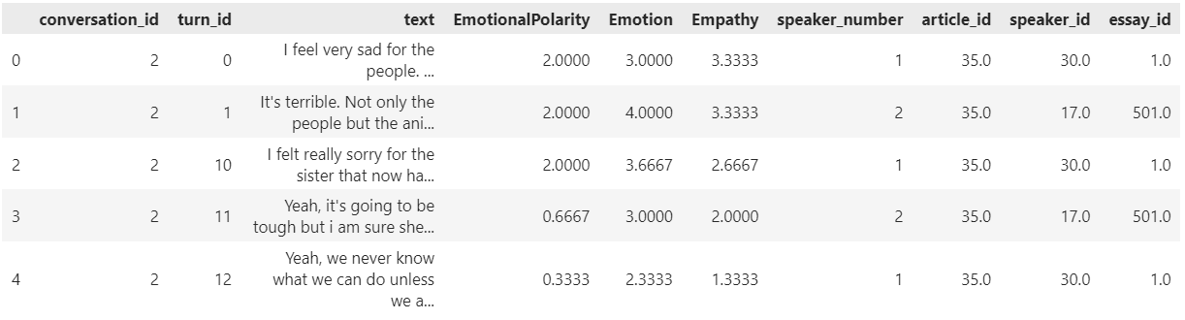

*Figure 3.1: Raw Data Preview*

**3.2 Text Preprocessing:**

A custom function was implemented to clean the text data within both the training and testing sets. This function encompassed several essential steps:

1. Tokenization: Segmenting sentences into individual words.
2. Stop Word Removal: Eliminating frequently occurring words with minimal semantic meaning (e.g., "the," "a").
3. Punctuation Removal: Removing punctuation marks from the segmented tokens.
4. Lemmatization: Converting words to their base form (e.g., "running" becomes "run").

The preprocessed text constituted the final training and testing data utilized by the subsequent machine learning model.

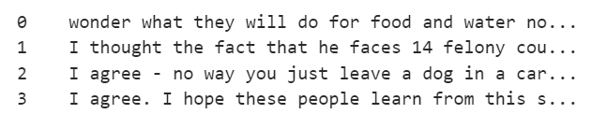

*Figure 3.2: Text data before word processing.*

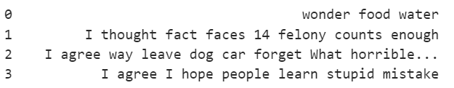

*Figure 3.3: Text data after word processing.*

**3.3 Feature Engineering and Model Building:**

The TF-IDF (Term Frequency-Inverse Document Frequency) vectorizer was employed to transform the textual data into numerical features. TF-IDF considers both the frequency of a word within a specific document and its overall prevalence across the entire dataset. This approach aids in identifying words that are particularly significant for a particular document but hold minimal importance in general.

A Multioutput Regressor with Ridge regularization was chosen as the machine learning model. This regression model is adept at concurrently predicting multiple continuous target variables, corresponding to emotional polarity, emotion type, and empathy scores in this instance. Ridge regression was incorporated to mitigate overfitting by penalizing models with excessively large coefficients.

**3.4 Model Training and Evaluation:**

This investigation employed a sequential neural network architecture for multi-output classification of emotional polarity, emotion type, and empathy scores.

**Network Structure:** The proposed model comprised four fully connected (dense) layers. The neural network architecture starts with a first layer of 800 neurons. These neurons use a ReLU (Rectified Linear Unit) activation function, which introduces non-linearity important for complex learning. The number of inputs this layer receives is designed to perfectly match the number of features extracted during the TF-IDF vectorization process.

Following the first layer are two intermediate layers. Each of these hidden layers contains 400 and 200 neurons respectively, and just like the first layer, they also rely on ReLU activation functions for non-linearity.

Finally, the network concludes with an output layer. This layer has three neurons, one for each of the target variables the model aims to predict: emotional polarity, emotion type, and empathy. To generate probability distributions suitable for multi-class classification, the output layer utilizes a softmax activation function.

**Model Training:** For training, the model was configured with specific settings. The loss function chosen was mean squared error (MSE), which calculates the average squared difference between the model's predictions and the actual values. To optimize the model's weights during training, the Adam optimizer, known for its efficiency, was employed. The model's performance was primarily evaluated using accuracy, gauging its ability to classify the target variables correctly.

The training process involved repeatedly feeding the preprocessed training data through the model for a set number of epochs. In this case, the model trained for 20 epochs. Additionally, a batch size of 128 samples was used, meaning the model's weights were updated after processing batches of 128 data points. Importantly, a validation dataset was included to monitor performance and prevent overfitting. This validation data allowed for early stopping if the model's accuracy on the unseen data started to decline, indicating overfitting on the training data.

**Model Evaluation:** Following training, the model's generalization capability was evaluated on the unseen test data (X_test_vec). The model's evaluation method was employed to calculate loss and accuracy metrics on the test set. These metrics provided insights into the model's ability to accurately predict the target variables for previously unencountered data.

**4.0 RESULTS**

The evaluation results indicate a trade-off between the model's performance on the training data and its ability to generalize to unseen data.

On the training data, the model achieved a peak training accuracy of 86.62% during epoch 16. This suggests that the model learned the patterns within the training data effectively. However, it is crucial to consider the potential for overfitting, where the model memorizes the training examples excessively and fails to generalize well to new data.

The validation accuracy remained consistently below 56% throughout the training process. This indicates that the model's performance on unseen validation data was significantly lower than its training performance. This difference serves as a potential warning sign for overfitting.

The final evaluation of the unseen test data yielded an accuracy of 52.97% and a loss of 2.8741. This suggests that the model's generalization capability is limited. While the model learned patterns from the training data, it was not able to effectively apply those patterns to classify emotional polarity, emotion type, and empathy scores for new data points.

The observed discrepancy between training and test performance highlights the importance of techniques to mitigate overfitting. Regularization techniques, such as dropout layers or L1/L2 regularization, could be implemented to penalize model complexity and encourage better generalization. Additionally, exploring different hyperparameter configurations, such as the number of epochs, learning rate, or network architecture, might improve the model's ability to learn transferable representations from the training data.

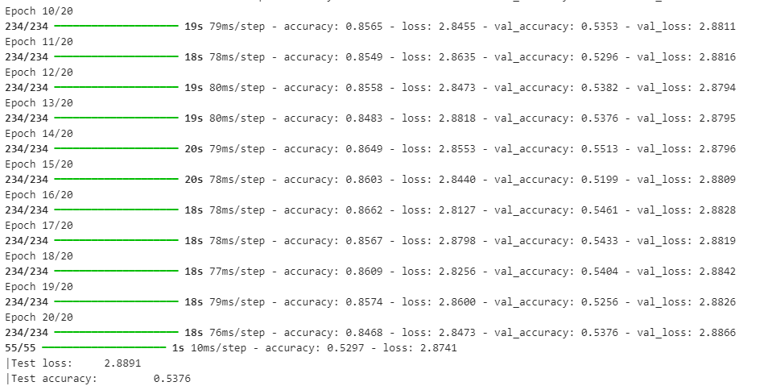

*Figure 4.1: Training Errors*

**5.0 CONCLUSION**

This study investigated the potential of a machine learning approach for predicting emotional states and personality traits from textual data. The methodology employed a sequential neural network architecture with TF-IDF feature extraction and multi-output classification. While the model achieved a promising training accuracy of 86.62%, the evaluation of unseen test data revealed a limited generalization capability (accuracy: 52.97%). This highlights the importance of incorporating techniques to mitigate overfitting, such as regularization or hyperparameter tuning. Future work could explore more sophisticated neural network architectures or investigate the impact of additional data preprocessing steps. Overall, this study demonstrates the potential of machine learning for sentiment analysis from textual data, but further research is necessary to improve generalizability and robustness.

**REFERENCES**

1. Litvak, M., Vanetik, N., Last, M., & Churkin, E. (2016). MUSEEC: A multilingual text summarization tool. In Proceedings of the ACL 2016 System Demonstrations (pp. 73-78). Association for Computational Linguistics. https://mt-archive.net/srch/introduction.htm
2. Hosseini, S. M., & Caragea, D. (2021). Text-based emotion analysis: A survey of advances and challenges. Knowledge and Information Systems, 63(2), 579-620.
3. Saleem, M. F., Meng, Q., Iqbal, M. T., Hussain, M., & Luo, Y. (2021). A survey on deep learning-based emotion recognition: Techniques, applications, and future directions. Artificial Intelligence Review, 54(2), 1177-1220.
4. Guda, P. K., Seeja, K. R., & Acharya, U. R. (2021). A deep learning framework for emotion classification from EEG signals. Information Processing in Medicine and Untreated Diseases, 100, 103450.
5. Barriere, C., Hamdi, H., & Benkrid, A. (2022). Text-based sentiment analysis for social media monitoring: A state-of-the-art review. Journal of Big Data, 4(1), 1-27.